

Log Filewalker

Contents
Quick Overview 3
Introduction 3
Features 3
Future enhancements 3
Short term: 3
Long term: 3
Before Execution 4
Execution Example 5
More details about Bottom-Left pane 7
Documentation 8
Overall Class Diagram 8
Parse Sequence Diagram 9

Quick Overview

Introduction
LFW is a parsing tool for SSM client (Gateside, SSM) log files. It analyzes log files and provides a detailed report of the sequence of events found, organizes them in a tree-based structure, and provides a UI that allows to go through the log file in an easy way.
It is written in Java 1.6, using JUnit 4 and Windows Builder Eclipse plugin.
LFW is a work in progress, so you should expect to find bugs in this Beta version.

Features
- Quick parsing (>3.5 MBs).
- Opens multiple files.
- Auto-scroll to selected event (from tree to log file text).
- Inverse auto-scroll (from log file text to tree)
- Log file, Application session, user session and State statistics.
- Line wraping avoids horizontal scrolling.
- Word searcher.

Future enhancements

Short term:
- Complete the configuration menu in order to provide personalized parsing options, among other features.
- Upload to a repository and provide access to other HP/AA programmers.
- Generate complete project documentation.
- Full code clean and enhancement. Minor bug fixes.
- Enhance memory usage.

Long term:
- Implement ability to parse server log files.

Before Execution

In order to understand use the program correctly, it is necessary to know the data structure of the client logs.
They use a tree data structure as it follows:
- Log File: It is the regular log file that the SSM application stores on disk. It can contain multiple Application Sessions.
- Application Session: A new application session begins every time the SSM application is started. It can contain User Sessions, exceptions or states.
- User Sessions: A user session is considered to begin when the user successfully logs in in any of the possible ways. It can contain States or Exceptions.
- States: Different states are associated with the different stages of the stateprocess flow. They are followed one after the other.
- Exceptions: Are regular Java exceptions.
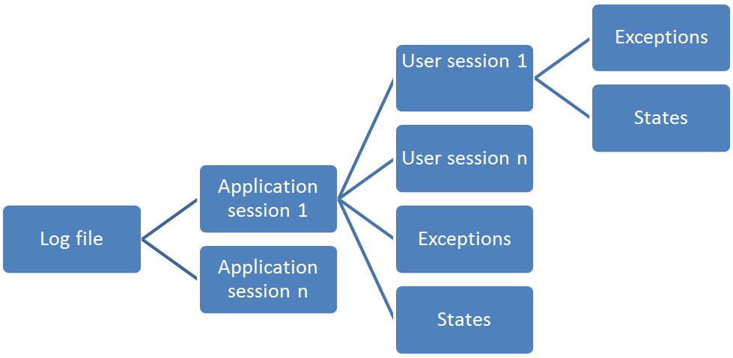

Execution Example
- Execute Logfilewalker v1.1.jar
- To open a log file, go to the top menu and click:
Menu->Open File
- Browse and browse for a valid “SSMApplet.log” file. (The following execution screenshots, are from the SSMApplet.log file attached along with this document. If you want to try with a different log file, please make sure it is smaller than 20MB or the JVM will run out of memory. This will be fixed soon).
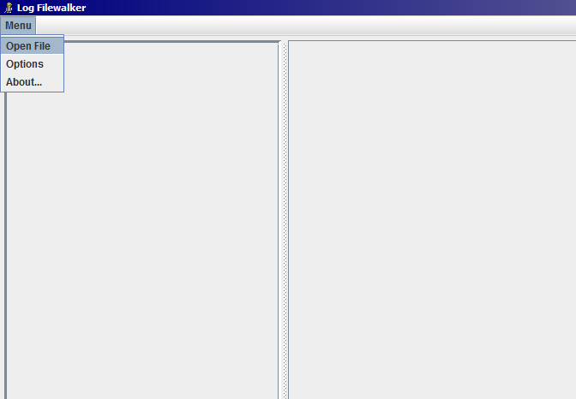
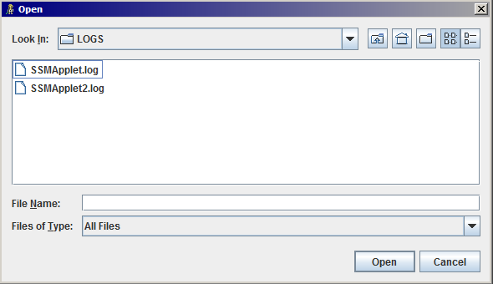
- Once the file is open, the screen will be split in three parts:
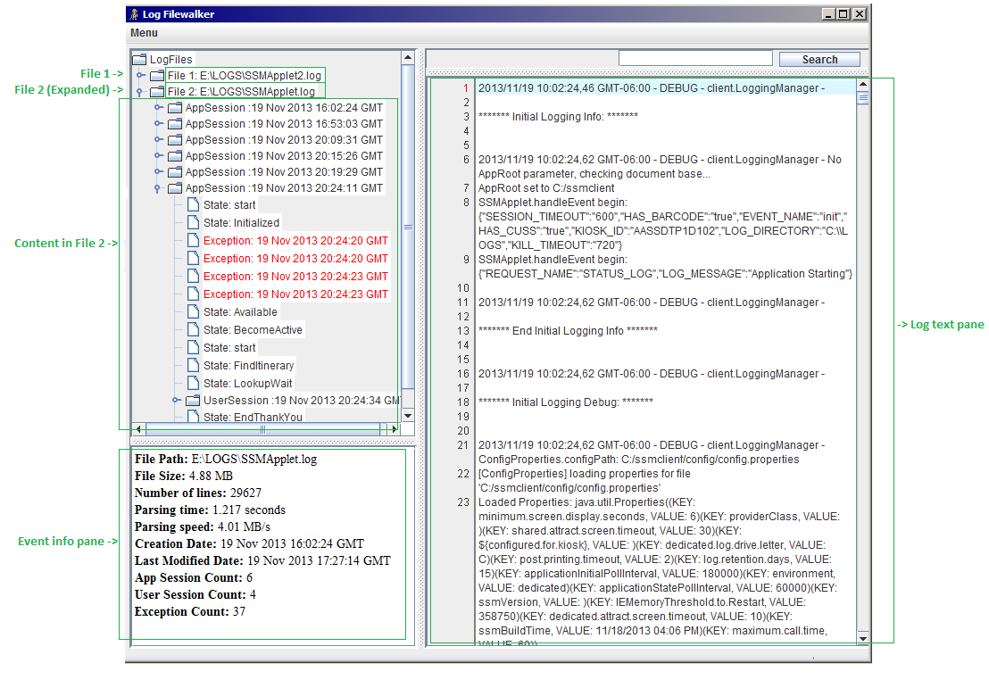
Top-Left Pane: A JTree containing the logs structure. In this example, two log files were opened: The first one is collapsed in the tree, and the second one is expanded.
It can be seen that inside the second file, there are 6 Application Sessions. All of them are collapsed, except for the last one. The last Application Session contains exceptions, states and one User Session (which is collapsed too).

Bottom-left pane: It contains information of the currently selected event. In the screenshot, the second file is selected, so this pane shows information about it. If other event was selected from the tree, the content of this pane would automatically change.
Right pane: It contains the log file in its original format. It also provides line wrapping to avoid scrolling horizontally, line enumeration and a word searcher. Whenever you click an event form the Jtree, this pane will automatically scroll to the line where the event starts in the log file.
The right pane also provides a “reverse-scrolling” functionality. This is: If the user clicks on a random line of the log file, then the Jtree will automatically scroll and expand the leaf of the event associated with that line. This allows the user to find out exactly what part of the state process and application session he is looking at.

More details about Bottom-Left pane
As it was mentioned, this pane provides extra information about each event selected on the tree. This information is gathered from the file during parse time. Here are some examples of different events:
Log File:
File Path: E:\LOGS\SSMApplet.log
File Size: 4.88 MB
Number of lines: 29627
Parsing time: 1.217 seconds
Parsing speed: 4.01 MB/s
Creation Date: 19 Nov 2013 16:02:24 GMT
Last Modified Date: 19 Nov 2013 17:27:14 GMT
App Session Count: 6
User Session Count: 4
Exception Count: 37

Application Session:
Start Date: 19 Nov 2013 20:24:11 GMT
Start Line: 26239
End Date: 26 May 2014 17:43:25 GMT
End Line: 29626
User Session Count: 1
State Count: 73
Exception Count: 4
ticket-stock-name: Preprinted narrow roll
scan-device-type: SIHU
check-in-host-environment: CERTD
airport-code: DFW
default-language: English
primary-printer-tA: AF94DA
password: AA001
passport-device-type: PSFDV
country-code: US
card-device-type: CSVUD
device-type-name: KINA
foid-type: UNMASKED
URL: http://10.88.9.10/SSMServer6/xmlrpc
confirm-standby-cutoff-mins: 720

User Session:
Start Date: Tue Nov 19 17:24:34 ART 2013
Start Line: 27494
State Count: 64
Exception Count: 0
PNR: IPQRGA

State:
Starting Line: 27309
Starting Date: Tue Nov 19 17:24:24 ART 2013
State: Available
Trigger: active
Guard Result :true
Target State: BecomeActive

Documentation

Overall Class Diagram
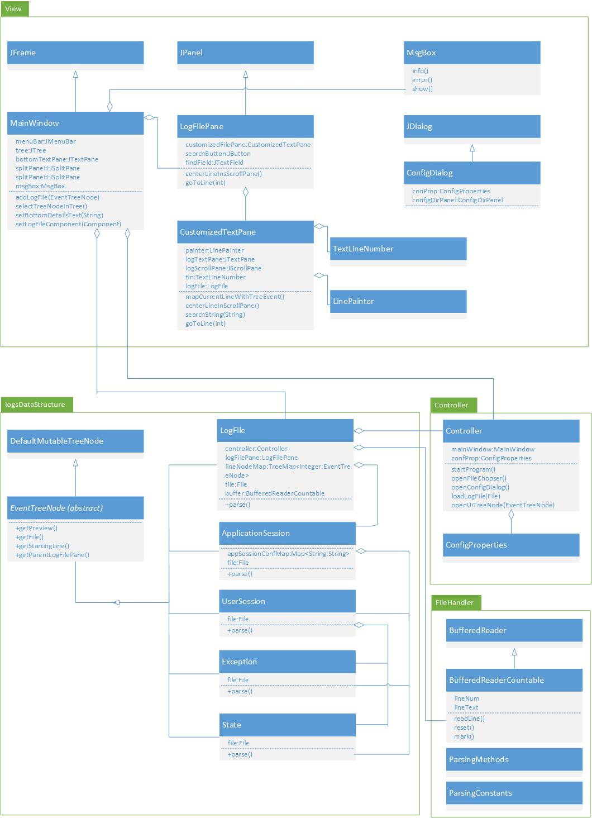

Parse Sequence Diagram
